Taris Major
Dr. Mahmoud Eldefrawy
Machine Learning
24 November 2025

Assignment 3 - FCNNs vs CNNs on CIFAR-10
The main focus of this project is to understand the practice and key concepts behind Neural Networks that represent the state-of-the-art technology of machine learning. The two types of neural networks explored in this project are Fully Connected Neural Networks (FCNNs) and Convolutional Neural Networks (CNNs). A fully connected neural network (FCNN) is a powerful and versatile architecture that can be applied to a wide range of datasets. Convolutional Neural Networks (CNNs) are designed to take advantage of spatial structures in data, such as images.
In this project, neural networks were created with hyperparameters tuned to improve generalization and avoid overfitting. Existing architectures were used to compare which one had the best learning curve and best model. For FCNNs, the architectures explored were: Adam, Adamw, Nadam, and RMSProp. For CNNs, the architectures explored were: LeNet, AlexNet, VGG and Xception. This project focused over the CIFAR-10 dataset which is a relatively small set of 60,000 color images divided into 10 object categories designed for image classification.
Methodology
In all of the neural networks created, a Keras environment was installed with a jax backend. The CIFAR-10 dataset was then imported and loaded into training and testing variables. Where necessary, the training and testing data was normalized and formatted to compliment that particular architecture. For instance, since FCNNs require the images to be 1D arrays, we must flatten the 2D images to 1D arrays before feeding them to the FCNN architecture. Each FCNN and CNN architecture was then recreated and compiled with their respective optimizers, the loss being Sparse Categorical Crossentropy and the metrics being focused on Accuracy. A validation set was then sectioned from the training dataset where the training dataset is the first 45,000 images, and the validation set is the last 5,000 images. A “history” variable was then made to store the accuracy of the model created with varying epochs. So that a nice graph can be drawn, the epochs were standardized to 40. Two graphs were then generated from the data stored in history: Accuracy and Loss. From these graphs we are able to visualize the Underfit, Optimal fit and Overfitting areas. From this visualization, another model was trained on the same parameters but limited to the optimal epochs needed to create the best generalized model. This new model was then saved on the virtual machine and stored in Google Drive.
Results
A notable observation made when training FCNN models and CNN models is the time disparity between epochs. Since CNN architectures are much more intense, they have taken a much longer time to train when compared to FCNN models. FCNN models usually take about 8-30ms of training per epoch, CNN took considerably longer. On average: LeNet took 128s per epoch, VGG took 1040s per epoch, AlexNet took 1400s per epoch, and Xception forecasted 11 hours to complete an epoch which took too long to complete so there is no data using Xception architecture.
Starting with FCNN models trained on the CIFAR-10 dataset, these are the graphs generated and the best performing models:

- Nadam
Nadam was the best performing model generated with an accuracy of 46.78%. Though this result is not great (or good), this kind of result is to be expected from FCNN models trained on images. FCNN architectures are better used on text data than images. These are the graphs generated:
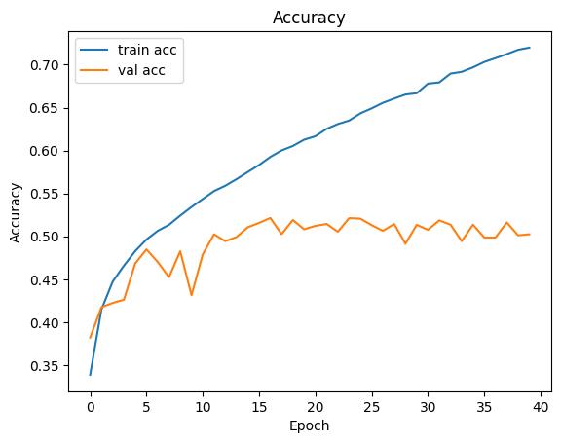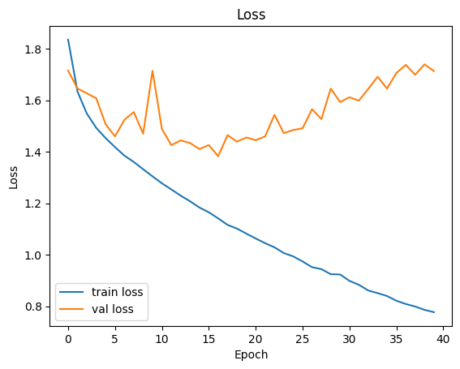
We see from these graphs that around 3-4 epochs is when the model starts to overtrain on the data, so the new model is trained up to 4 epochs and saved to Google Drive.
- AdamW
AdamW was the second best performing model generated with an accuracy of 44.71%. The graphs generated are:
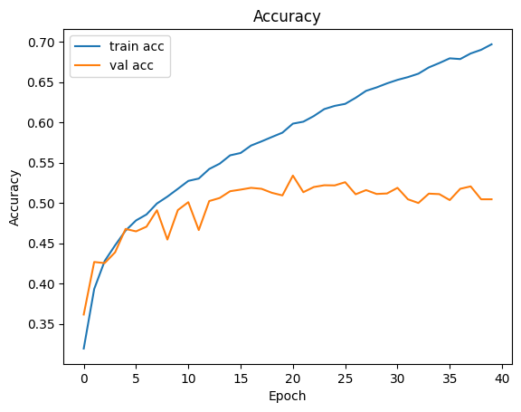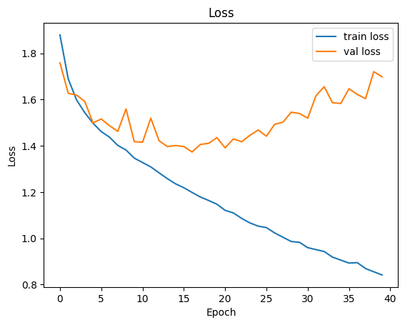
We see from these graphs that around 4-5 epochs is when the model starts to overtrain on the data, so the new model is trained up to 4 epochs and saved to Google Drive.
- Adam
Adam was the third best performing model generated with an accuracy of 42.56%. The graphs generated are:
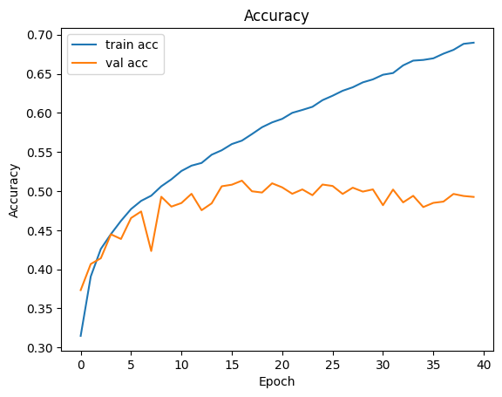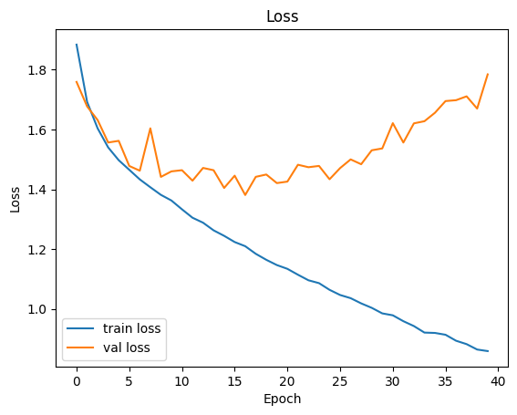
We see from these graphs that around 3-5 epochs is when the model starts to overtrain on the data, so the new model is trained up to 3 epochs and saved to Google Drive.
- RMSProp
RMSProp was the worst performing model generated with an accuracy of 36.79%. The graphs generated are:
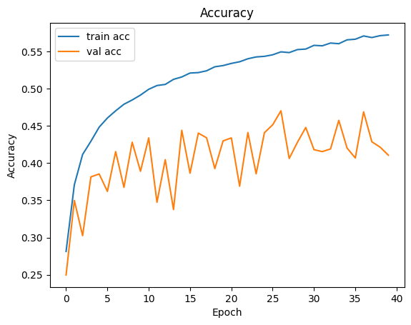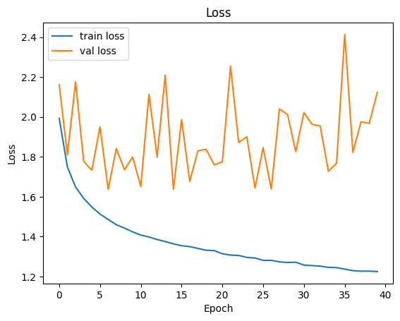
We see from these graphs that after the first epoch the model starts to overtrain on the data, so the new model is trained on one epoch and saved to Google Drive.
Moving onto CNN models trained on the CIFAR-10 dataset, these are the graphs generated and the best performing models excluding Xception:
- VGG
VGG was the best performing model generated with an accuracy of 66.94%. This result is not great (or good) for CNN models trained on images. As a CNN, 80-90% is expected, there could be various reasons for this number being so low. The number of epochs remained the same between FCNNs and CNNs. More layers, more epochs, or a different optimizer could give better results. These are the graphs generated:
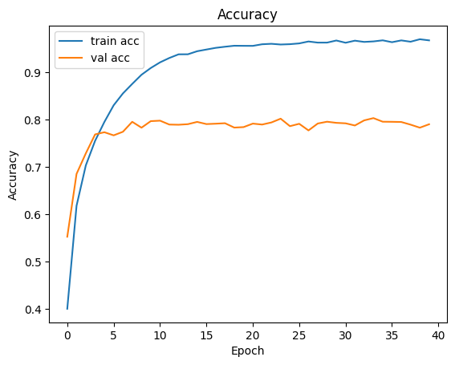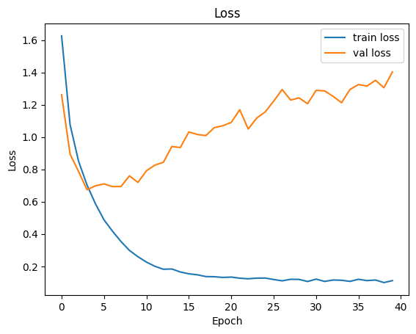
We see from these graphs that around 2-3 epochs is when the model starts to overtrain on the data, so the new model is trained up to 3 epochs and saved to Google Drive.
- LeNet
LeNet was the second best performing model generated with an accuracy of 65.76%. The graphs generated are:
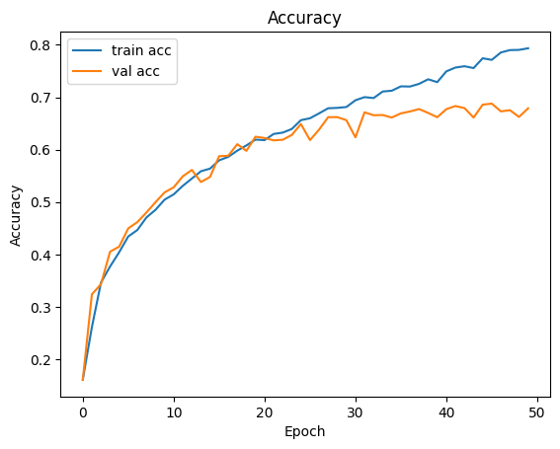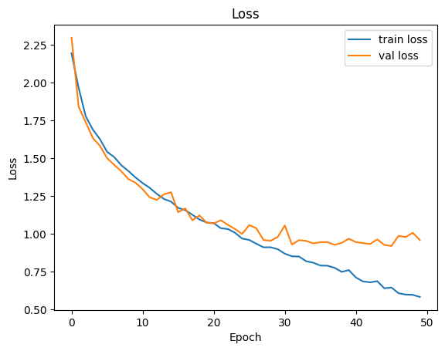
We see from these graphs that around 23-26 epochs is when the model starts to overtrain on the data, so the new model is trained up to 25 epochs and saved to Google Drive.
- AlexNet
AlexNet was the third best performing model generated with an accuracy of 60.23%. The graphs generated are:
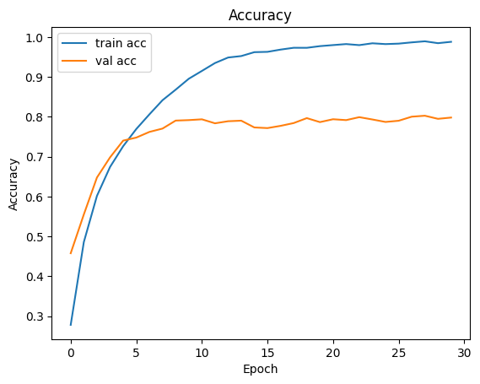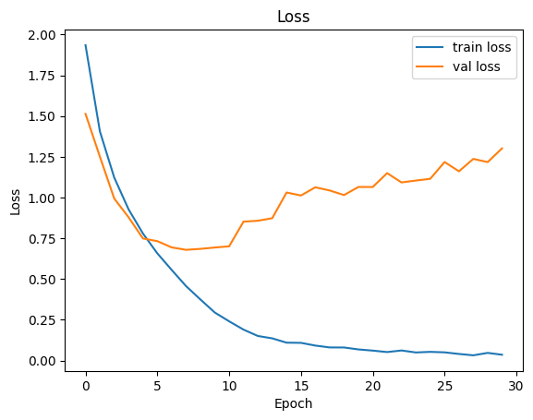
We see from these graphs that around 3-5 epochs is when the model starts to overtrain on the data, so the new model is trained up to 3 epochs and saved to Google Drive.

Conclusion
This project shows the vast performance differences between FCNNs and CNNs when trained on the CIFAR-10 image dataset. It is shown that FCNNs struggle to capture spatial image data, resulting with poor accuracies across all optimizers tested. Nadam performed the best on the dataset with an accuracy of 46.78%, which emphasizes the limitations of FCNNs on images.
CNNs on the other hand is specifically designed to exploit spatial datasets like images, and gives significantly better results. VGG produced the best performing model with an accuracy of 66.94%. Though CNNs performed better, none of the models were able to get above 80% which should be expected. This indicates that there can be improvements made like modifying different hyperparameters or using other optimizers. CNNs took significantly longer per epoch than FCNNs. Which indicates that between FCNNs and CNNs, the better the accuracy, the more computationally expensive it is to complete.

